Command Torque Repartition Algorithm

# 1 System description

The algorithm is implanted on the Simulink model as a matlab function. It calls different files .mat (fa_differential_ratio.mat, fa_gearbox_ratio .mat, ra_differential_ratio.mat, SP_elec.mat, SP_therm.mat, Tab_poly_elec.mat, Tab_poly_therm.mat) which contains datas which must be loaded in the workspace of the function (the matlab workspace and the function are different and each function has her own workspace).

With the matlab function, the model runs in ~55 minutes because it compile in C code at each sample time. To decrease the calculation time (less than 3 minutes), a sfunction of the algorithm is created (a sfunction contains c code and runs faster than a matlab function because it is not compiled at each saple time). The sfunction is created for a 32 bits or 64 bits version depending on the computer used. To generate the sfunction in your corresponding version you may follow the following steps :

* double click on the block

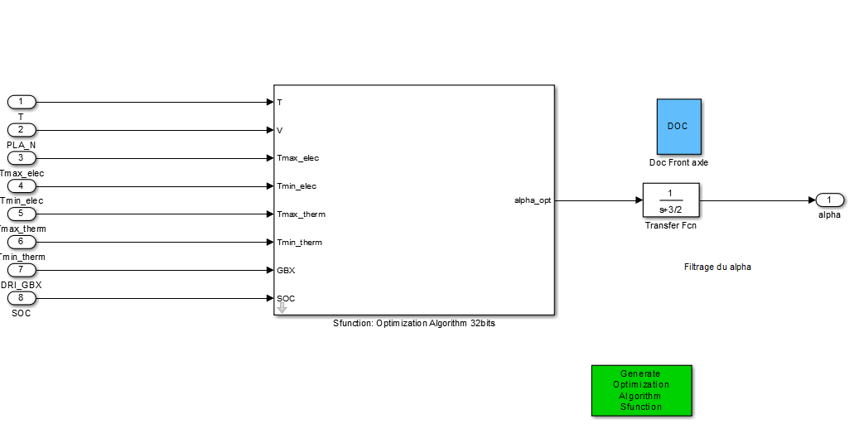

* right click on the matlab function
* 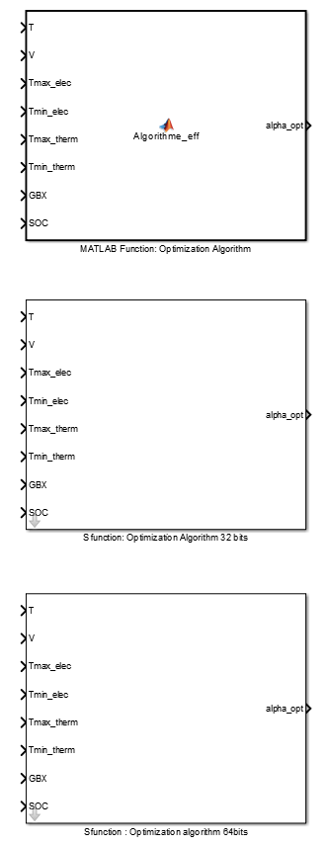
* C/C++ code
* click on Generate S-Function
* click on build

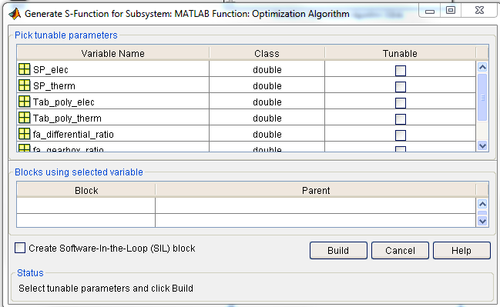

* Copy the block created

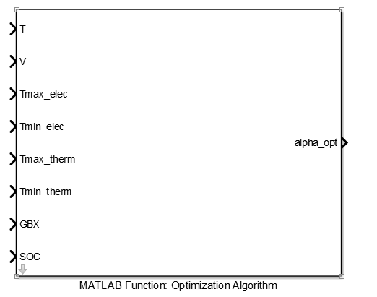

* Paste it in HEV model/Command/Torque repatition/Optimization Algorithm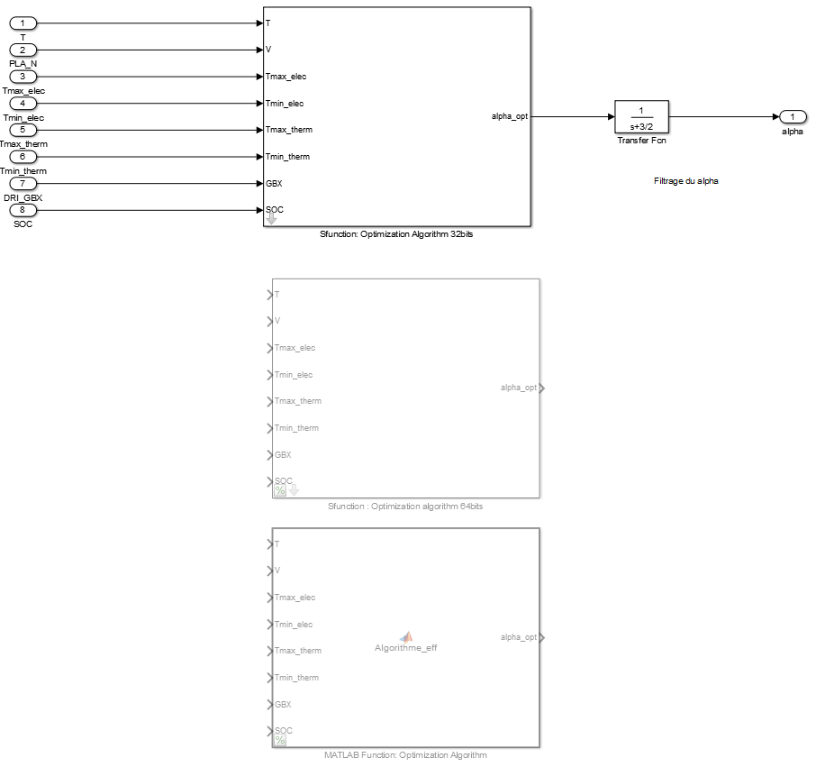
* The sfunction in the model 5.0 (in Optimization_Algorithm.mdl)were generated with matlab 2013a (32 bits version) and matlab 2014b (64 bits version)